CS450 - Assignment Two

Andrew Struthers April 2023

1. Calculate the propagation delay and RTT for a 100m copper link.
   * This problem will require us to calculate the propagation delay and the Round Trip Time (RTT) using the following equations:

Propagation Delay = Link Length (meters) *×* Copper SoL Coeff. (1) RTT = 2 *×* Propagation Delay (2)

We can see the following calculations performed in Excel below.

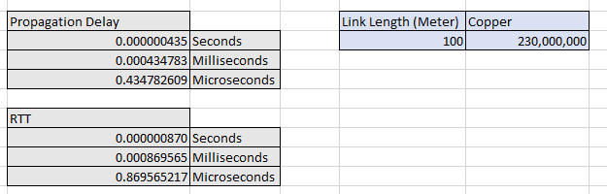

Figure 1: Propagation delay and RTT for a 100m copper link

We can see that the propagation delay was *≈* 0*.*44*µs* and the RTT was *≈* 0*.*87*µs*.

1. How many IP packets will it take to transfer a 150 GB file?
   * For this problem, we will be looking at the following equation:

Packets = *⌈*File Size (Bytes)*/*Maximum Segment Size (MSS)*⌉* (3)

We want to take the ceiling of the division because any remainder will still need its own packet, so we always take the next highest integer result.



Figure 2: Number of packets to send a 150 GB file over Ethernet

The MSS for Ethernet is 1460, therefore we divide the number of bytes in the file by 1460, take the ceiling of that result, and bam, we have the number of packets being transmitted. In this case, it will take *≈* 110*.*3 million Ethernet packets.

1. What is the total time required to send a 100 GB file over the following network: A 60m copper link with 10 Gbps bandwidth, to a 1,800km fiber link with 40 Gbps bandwidth, to a final 90m copper link with 1 Gbps bandwidth. Assume that each switch is a store-and- forward switch that introduces a 40 *µs* delay between packets, and a 3 RTT handshake is required before data can be transmitted.
   * This problem is a bit more complex to solve than the previous two. We will use equation

(1) and (2) above to calculate the RTT for each stage in this network. We will also need to calculate the transmit time with the following equation:

Transmit Time = File Size (bits)*/*Bandwidth (bps) (4)

Notice that the file size must be in bits, but we are given the file size in bytes. We will perform an in-line calculation to change the units by multiplying the file size in bytes by 8, since there are 8 bits in a byte. We will also use equation (3) to calculate the number of required packets. Finally, we will need three new equations to calculate the total switch delay, the total RTT for the entire network, and finally the total transfer time. These are given by the following equations:

Total Switch Delay = Number of Packets *×* Switch Delay (5) Total RTT = (4 *×* Switch Delay) + Link 1 RTT + Link 2 RTT + Link 3 RTT (6)

Total Transfer Time = (3 *×* Total RTT)

+ (2 *×* Total Switch Delay)

+ Link 1 Delay + Link 2 Delay + Link 3 Delay (7)

To begin with the calculation for this problem, we will first determine the three indi- vidual components of this network to find each RTT and transmit time.

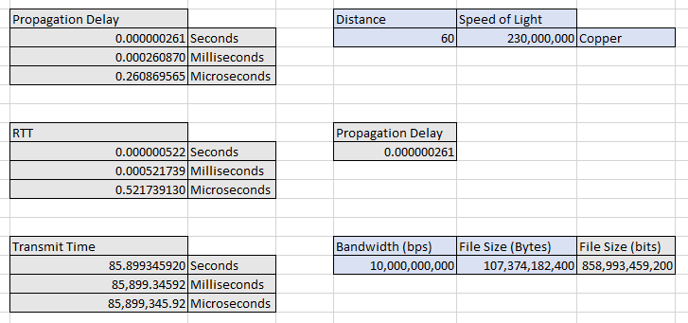

Figure 3: RTT and transmit time for a 100 GB file over 60m of copper with 10 Gbps

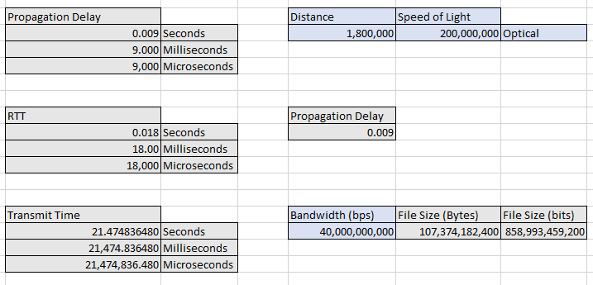

Figure 4: RTT and transmit time for a 100 GB file over 1,800km of fiber with 50 Gbps

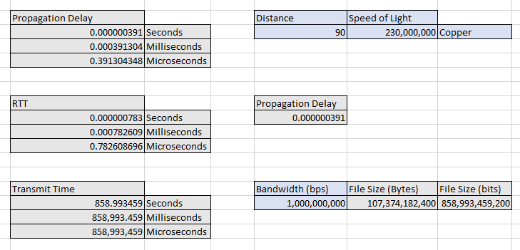

Figure 5: RTT and transmit time for a 100 GB file over 90m of copper with 1 Gbps

Now that we have the numbers for each individual component of the network, we must calculate some information about the network as a whole.

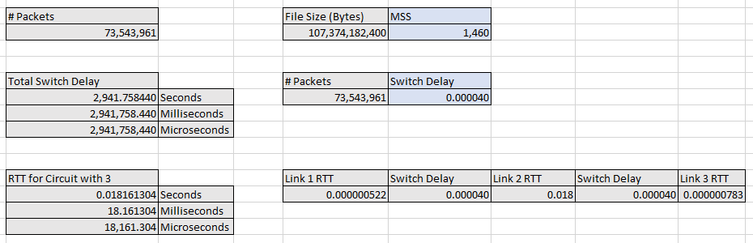

Figure 6: Number of packets, total switch delay, and the total RTT for the network

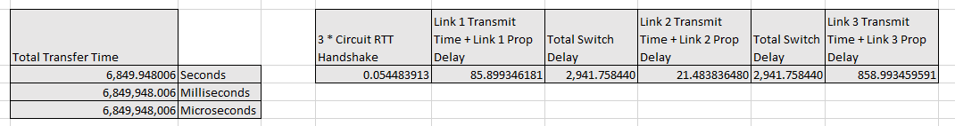

Figure 7: Total transfer time of the 100 GB file over the network

Looking at Figure 7, we can see that the total transfer time of the 100 GB file over this vast distance is *≈* 6*,* 850 seconds, or just over 1 hour and 54 minutes.

1. What is the maximum number of bits that could be in a 100 Mbps satellite link? The satellite is 36,210km above the earth’s surface.
   * The equation for this problem will be as follows:

Delay *×* Bandwidth = Link Length *×* Bandwitdth (bps) *×* Vacuum SoL Coeff. (8) Below we can see the calculation performed in Excel:

Figure 8: Total number of bits that would be floating through space

This calculation shows us that at any given point in transmission, there could be 24 million bits of this file floating through space. This is 3 MB, which honestly doesn’t seem like that much. I initially expected there to be far more bits over 36k km.

*≈*

*≈*